***STRUCTURE OF C*** ***1***

C is a general-purpose programming language that is extremely popular, simple and flexible. It is machine-independent, structured programming language which is used extensively in various applications.

C was the basics language to write everything from operating systems (Windows and many others) to complex programs like the Oracle database, Git, Python interpreter and more.

**STRUCTURE OF C PROGRAMMING**

**1.**Document section

**2.**Link section

**3.**Defination section

**4.**Global variable declaration

**5.**Main() function

**{**

1. declaration part
2. execution part

**}**

**6.**Subroutine or user defined function section

**SOME EXAMPLES**

Q.1) Write a c program to display “hello world”.

**Program**

// c program to deploy "hello world"

#include <stdio.h>

int main()

{ ***2***

printf("Hello World");

return 0;

}

**Output**

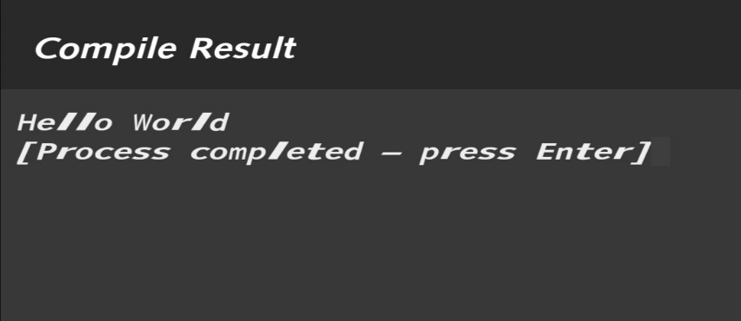

Q.2) Write a c program to add integer and display the sum.

**Program**

// c program to add two integer and display the sum

#include <stdio.h>

int main()

{ int a=5,b=6,c;

c=a+b;

printf("Sum of %d and %dis %d",a,b,c);

return 0;

}

***3***

**Output** 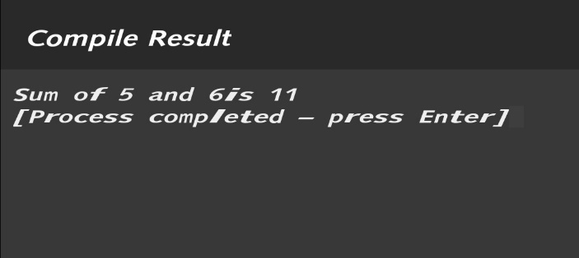

Q.3) Write a c program to multiplay two integer and display the result.

**Program**

// c program to multiply two integer and display the result

#include <stdio.h>

int main()

{

int a=7,b=9,c;

c= a*b;

printf("Multiplication of %d %d is %d",a,b,c);

return 0;

}

**Output**

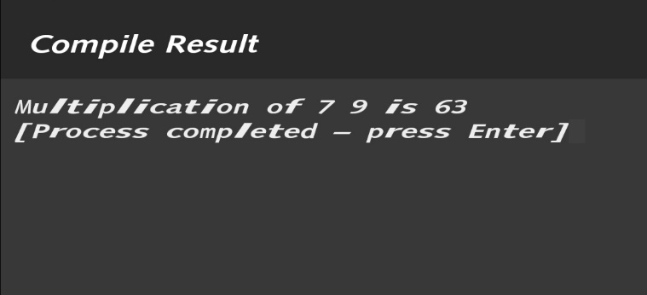

Q.4) Write a c program to convert celcius to farenheit.

**Program** ***4***

// c program to convert celcius to farenheit

#include <stdio.h>

int main()

{

int a=27,b;

b=9*a/5+32;

printf("%d celcious to farenheit is %d",a,b);

return 0;

}

**Output**

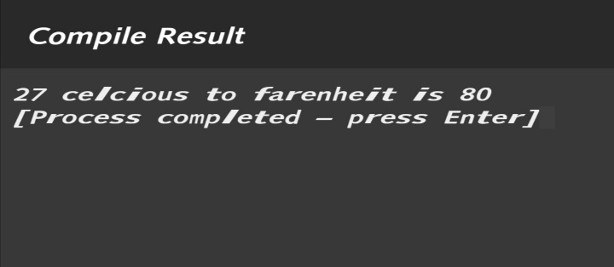

Q.5) Write a c program to convert feet to inches.

**Program**

// c program to convert feet to inches

#include <stdio.h>

int main()

{

int a=9,b;

b= a*12; ***5***

printf("%d feet to inches is %d",a,b);

return 0;

}

**Output**

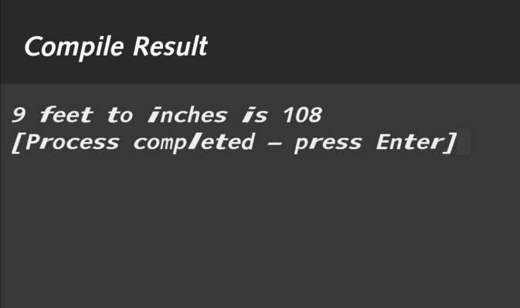

Q.6) Write a c program to calculate simple interest.

**Program**

//c program to calculate simple intrest

#include <stdio.h>

int main()

{

int p,t,r,intr;

printf("Enter principle: ");

scanf("%d",&p);

printf("Enter time: ");

scanf("%d",&t);

printf("Enter rate: ");

scanf("%d",&r);

intr= p*t*r/100; ***6***

printf("Intrest is:%d",intr);

return 0;

}

**Output**

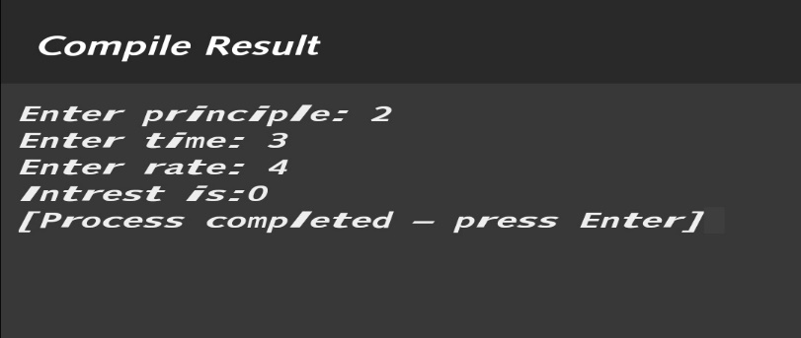

Q.7) Write a c program to calculate area and volume of cube.

**Program**

//c program to calculate area and volume of cube

#include <stdio.h>

int main()

{

int l,area,volume;

printf("Enter length: ");

scanf("%d",&l);

area=6*l*l;

volume=l*l*l;

printf("Area is: %d",area);

printf("\nVolume is: %d",volume);

return 0; ***7***

}

**Output**

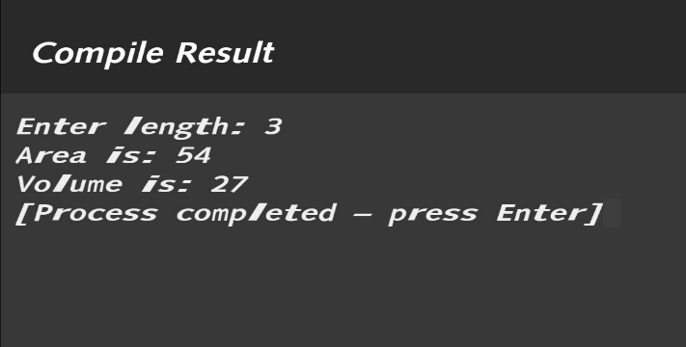

Q.8) Write a c program to check wether number is positive or negative or zero.

**Program**

//c program to check wether number is positive,negative or zero

#include <stdio.h>

int main()

{

int n;

printf("Enter a number: ");

scanf("%d",&n);

if (n==0)

printf("zero");

else if (n>0)

printf("positive");

else

printf("negative"); ***8***

return 0;

}

**Output**

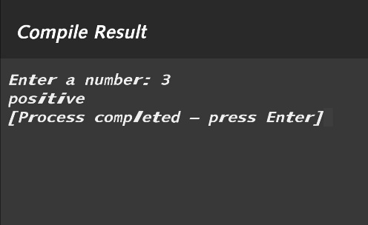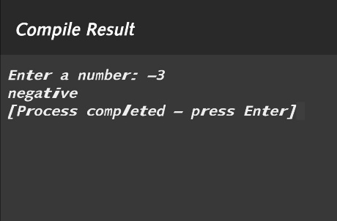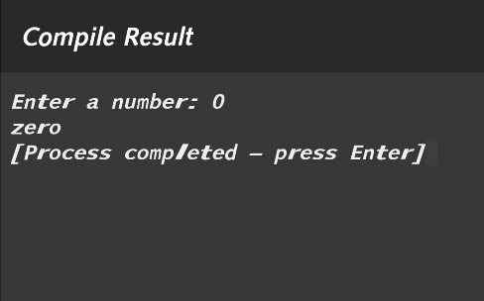

Q.9) Write a c program to evaluate sum of individual digit of three digit number.

**Program**

//c program to evaluate sum of individual digit of three digit number

#include <stdio.h>

int main()

{

int num,n1,n2,n3,sum,temp;

printf("Enter three digit number: ");

scanf("%d",&num);

temp=num;

n1=temp/100;

temp=temp%100;

n2=temp/10;

temp=temp%10; ***9***

n3=temp;

sum=n1+n2+n3;

printf("sum of %d individually is %d",num,sum);

return 0;

}

**Output**

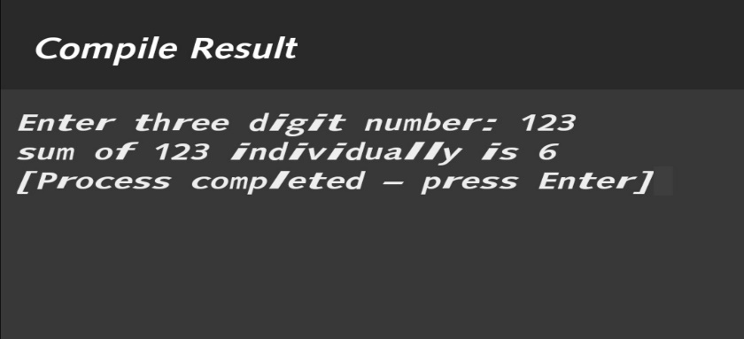

Q.10) Write a c program to test 153 is Armstrong number or not.

**Program**

//c program to test 153 is Armstrong number or not

#include <stdio.h>

int main()

{

int num=153,n1,n2,n3,sum,temp;

temp=num;

n1=temp/100;

temp=temp%100;

n2=temp/10;

temp=temp%10; ***10***

n3=temp;

sum=n1*n1*n1+n2*n2*n2+n3*n3*n3;

if (sum==num)

printf("153 is armstrong");

else

printf("153 isn't armstrong");

return 0;

}

**Output**

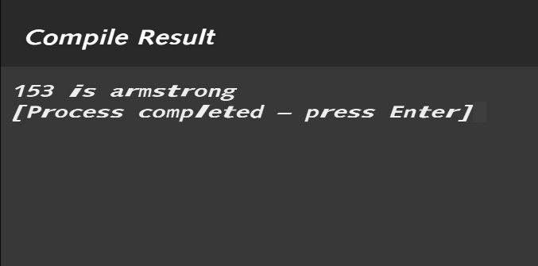

Q.11) Write a c program to find greatest number among given three digit.

**Program**

//c program to find greatest number among given three digit

#include <stdio.h>

int main()

{

int a,b,c;

printf("Enter 1st number: ");

scanf("%d",&a);

printf("Enter 2nd number: "); ***11***

scanf("%d",&b);

printf("Enter 3rd number: ");

scanf("%d",&c);

if (a>b && a>c)

printf("%d is greatest",a);

else if (b>c)

printf("%d is greatest",b);

else

printf("%d is greatest",c);

return 0;

}

**Output**

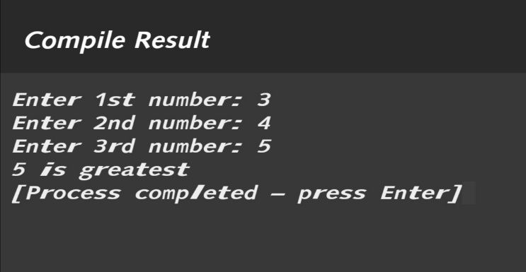

Q.12) Write a c program to evaluate given expression.

V=u+at

S=ut+1/2at2

**Program**

//c program to evaluate given expression

#include <stdio.h> ***12***

int main()

{

int u,a,t,v,s;

printf("enter u :");

scanf("%d",&u);

printf("enter t :");

scanf("%d",&t);

printf("enter a :");

scanf("%d",&a);

v=u+a*t;

s=u+a*t*t/2;

printf("v=%d",v);

printf("\ns=%d",s);

return 0;

}

**Output**

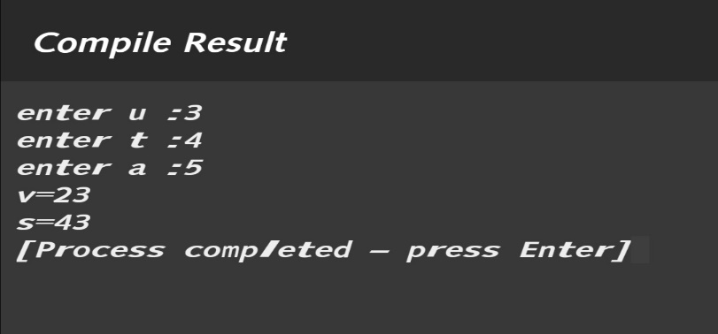

**THANK YOU**